## Roll

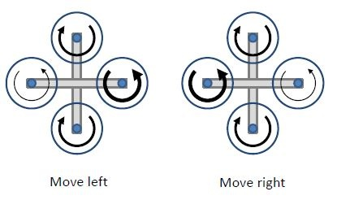

Figure 3.i: Roll (bold arrows show higher RPM)

Similarly to move right or left we follow the same principle of pitch that is increasing the speed of one motor with respect to another which is situated diagonally opposite to generate lift force causing imbalance of forces that generates momentum in one direction.